IMPULSIFIERS IMPACT ATTENUATOR DATA REPORT

Mr. Vaibhav Khante

Member, IMPULSIFIERS

**Impact Attenuator**

An impact attenuator is a structure used to “decelerate impacting vehicles gradually to a stop” by gradually decelerating the race car, the frame and driver are protected from significant deformation and injury. The bulk of impact energy is transferred into the deformation of the impact attenuator structure. Attenuators can be placed on vehicles or on road barriers to absorb large impacts to protect frames and people. FSAE specifies that each car in operation must have an attenuator that meets specifications and testing criteria.

**Design Tasks/ Specs**

There are many specific rules and regulations pertaining to all aspects of the vehicle, but this section provides information pertaining to the Impact Attenuator. The following information is referenced from section B3.20 of the 2010 FSAE Rules.

* The Impact Attenuator must be mounted forward of the Front Bulkhead. The surface of the attenuator must be over 200mm long (fore/aft of the frame), 100mm high, and 200mm wide. This will allow the Impact Attenuator to be a minimum distance of 200mm from the Front Bulkhead. An impact shall not cause the Impact Attenuator to penetrate the Front Bulkhead. It should be “mounted directly to the Front Bulkhead and not be part of non-structural bodywork“(2010 FSAE Rules, pg 24).
* The Impact Attenuator also must have 1.5 mm solid steel or 4.0mm aluminium Anti-Intrusion Plate built into the system. The Anti-Intrusion Plate may be bolted to the Front Bulkhead, but must be the same dimensions of the Front Bulkhead’s outer features. If the plate is bolted, it must use a minimum of four 8mm Grade 8.8 bolts. If the plate is welded onto the Front Bulkhead, it must extend at least to the centreline of the Bulkhead tubing. (2010 FSAE Rules, pg 24).
* The Impact Attenuator must adhere to the following data requirements, pertaining to section B3.21 of the 2010 FSAE Rules.
* The competition team is required to submit data displaying that the Impact Attenuator, when mounted on the Front Bulkhead, would give an average vehicle deceleration of less than 20g’s while hitting a non-yielding surface. The data requires the vehicle is travelling at 7 m/s during the impact with a total mass of 300 kg. The peak deceleration during the impact must be under 40g’s.

Team have submitted testing data, calculations, photos, and this materials in a PDF file.

**Theoretical calculations**

Values considered:

Vimpact =7m/s

Vfinal =0m/s

Mass(M) =360 Kg

For worst condition; taking average acceleration given in limitation.

i.e., average acceleration <= 20g

avg. accn = 20g = 196m/s2

Energy possessed by vehicle before impact is kinetic energy which will be needed to be absorbed by attenuator,

**Kinetic energy**= 0.5M (Vinitial2-Vfinal2)

=0.5*360*(72-0)

=8820 J

For impact testing drop height required so as to provide this value of kinetic energy; potential head required will be as follows;

potential energy(supplied)= kinetic energy(required) = M*g*Hd

* 8820=360*9.81*Hd
* **Hd=2.497m**

**Time of impact**

T = Vinitial/a

=7/196

=0.036 sec

**Impulse and force**

I= M * (Vinitial-Vfinal)

= 360(7-0)

=2520 Kg-m/s

F=I/t

=70000N

Attenuator strength required is,

Strength = force/area

=70000/50250 (area from attenuator specification)

=1.393 Mpa

**Experimental observations:**

Energy absorbed = area under force deflection = 35.7833 * 2000 * 28

=20,030 J

(**which is greater than required energy absorption)**

Maximum deflection =270.7mm =0.2707m

as,

Vfinal2 =Vinitial2-2as

0= 72-2*a*0.2707

a = 90.50m/s2 =9.225g (<20g)

Attenuator strength=2.307 Mpa

Load =F =11817 kgf

**APPENDIX B-2**

**IMPACT ATTENUATOR DATA REPORT – Page 1 of 3**

This form must be completed and submitted by **all teams no later than the date specified in the Action Deadlines onspecific event website**. The SUPRA SAEINDIA Technical Committee will review all submissions which deviate from the SUPRA SAEINDIA rules and reply with a decision about the requested deviation. All requests will have a confirmation of receipt sent to the team.Impact Attenuator Data (IAD) and supporting calculations must be submitted electronically in Adobe Acrobat Format(*.pdf). The submissions must be named as follows: schoolname_IAD.pdf using the complete school name. **Submit the IAD report as instructed on the event website.**

*In the event that the SUPRA SAEINDIA Technical Committee requests additional information or calculations, teams have **one weekfrom the date of the request** to submit the requested information or ask for a deadline extension.

University Name: SHRI RAMDEOBABA COLLEGE OF ENGINEERING AND MANAGEMENT

Car Number(s) & Event(s): 95

Team Contact: Suman Sourav E-mail Address: sumansourav1993@gmail.com

Faculty Advisor: Prof.B.C.Bissa E-mail Address:bcbissa@rknec.edu

|  |  |
| --- | --- |
| Material(s) Used | Aluminium Honeycomb |
| Description of form/shape | 260mm x 260mm x 240mm |
| IA to Anti-Intrusion Plate mounting method | Araldite |
| Anti-Intrusion Plate to Front Bulkhead mounting method | Welding |
| Peak deceleration (<= 40 g's) | 18.45g |
| Average deceleration (<= 20 g's) | 9.225g |

Confirm that the attenuator contains the minimum volume 200mm wide x 100mm high x 200mm long

yes

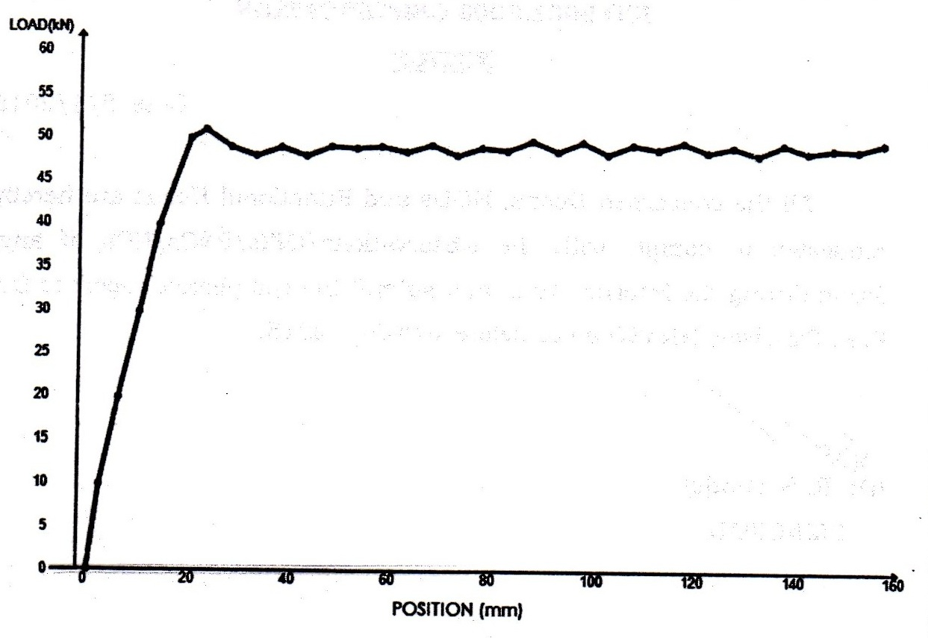

Figure 1: Force-Displacement Curve

**ATTACH PROOF OF EQUIVALENCY**

TECHNICAL COMMITTEE DECISION/COMMENTS

MIA TEST LAB & RESEARCH CENTRE ,MIA HOUSE,MIDC HINGNA AREA, NAGPUR-440028

Approved by- Harish Deshpande(Lab Incharge) Date_19/07/2014

**NOTE: THIS FORM AND THE APPROVED COPY OF THE SUBMISSION MUST BE PRESENTED AT TECHNICAL INSPECTION AT EVERY STUDENT FORMULA EVENT ENTERED**

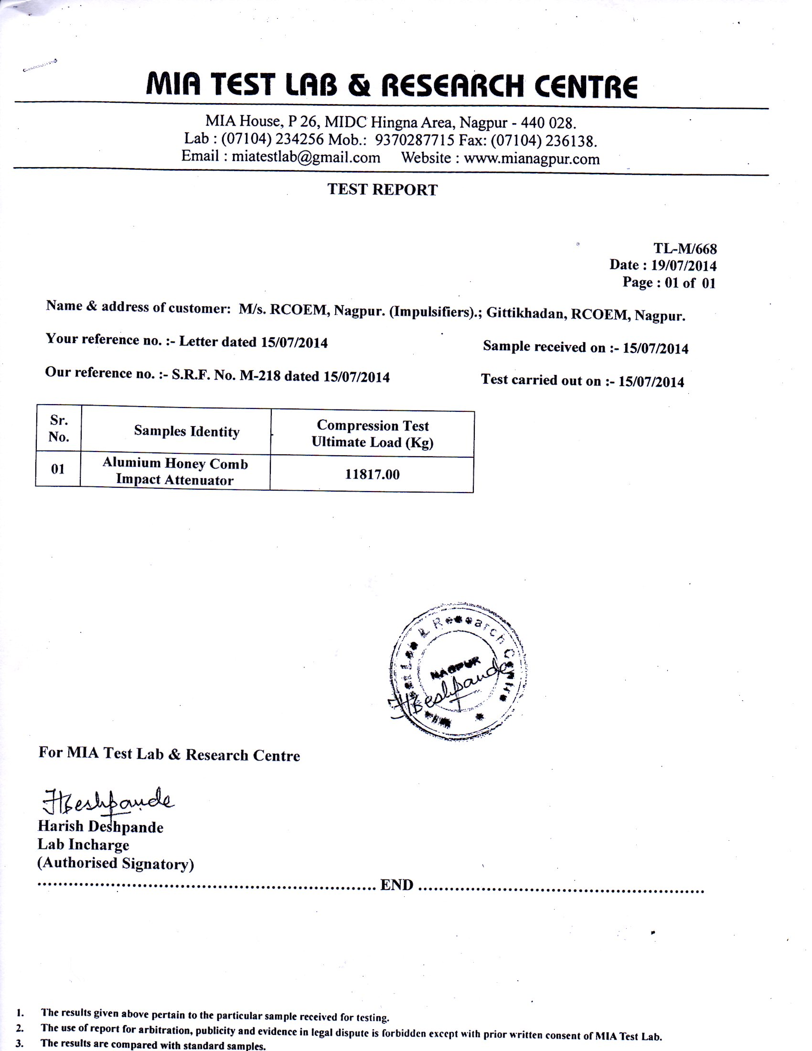

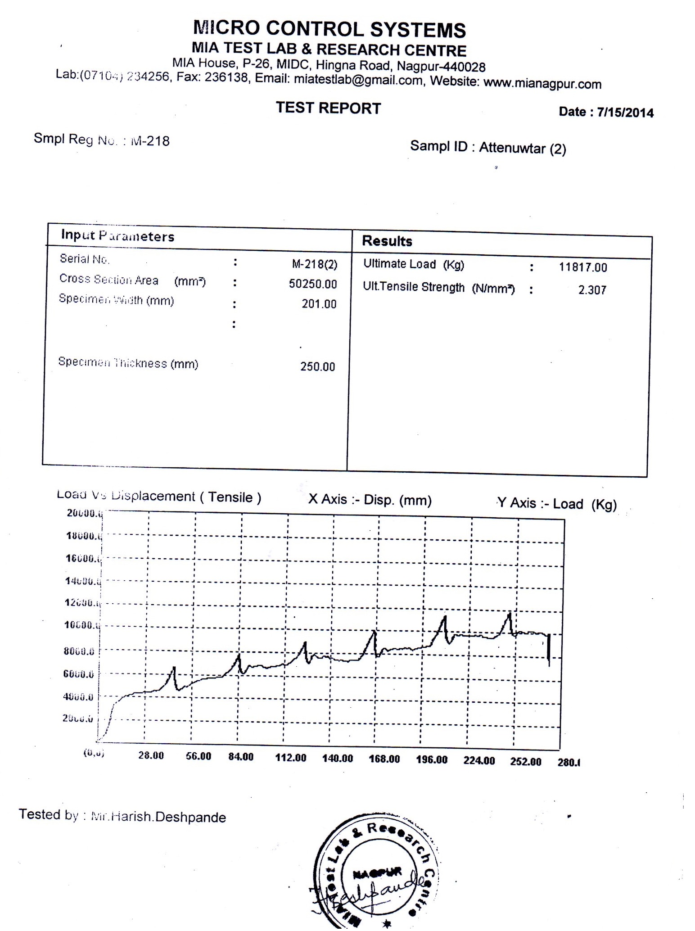

**APENDIX B-2**

**2015 SUPRA SAEINDIA IMPACT ATTENUATOR DATA REPORT – Page 2 of 3**

University Name: SHRI RAMDEOBABA COLLEGE OF ENGINEERING AND MANAGEMENT

Car Number(s) & Event(s): 95

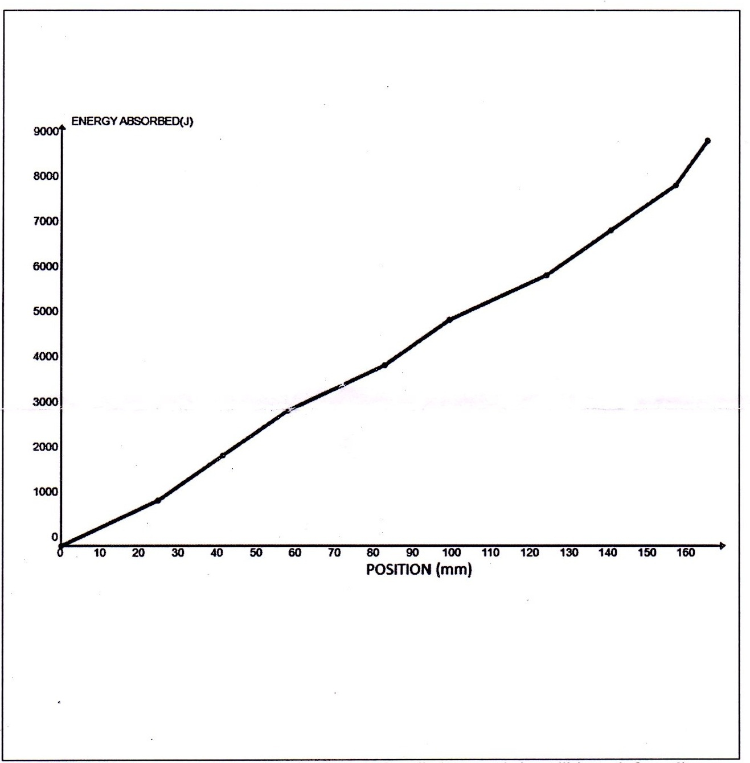

**Figure 2: Energy- Displacement curve**

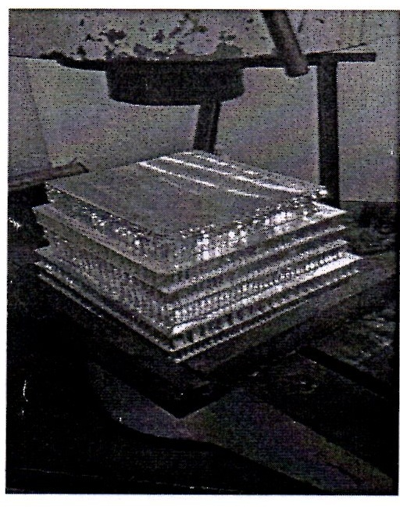 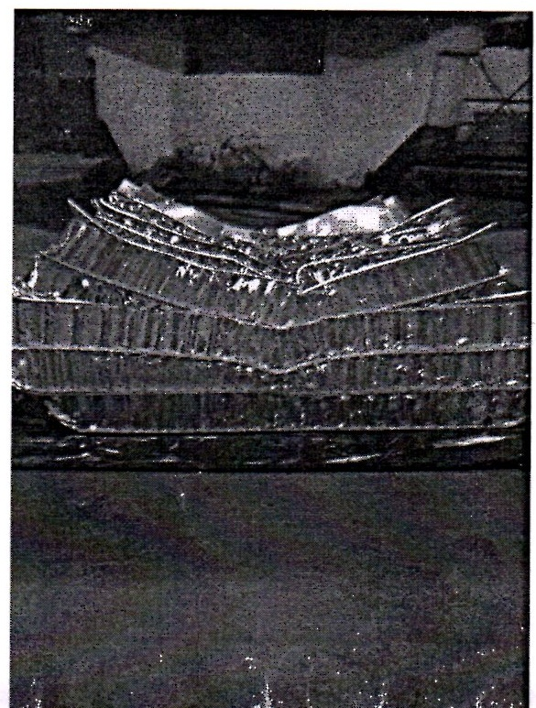

Figure 3: Attenuator as Constructed Figure 4: Attenuator after Impact

|  |  |  |  |
| --- | --- | --- | --- |
| Energy Absorbed (J):  Must be >= 7350 J | 8160J | Vehicle includes front wing in front of front bulkhead? | NO |
| IA Crushed Displacement (mm): | 160MM | Wing structure included in test? | NO |
| IA Post Crush Displacement - demonstrating any return (mm): |  | Test Type:(e.g. barrier test, drop test, quasi-static crush) | Quasi static crush test |
| Anti-Intrusion Plate Deformation (mm) |  | Test Site:(must be from approved test site list on website for dynamic tests) |  |

**APPENDIX B-2**

**2015 SUPRA SAEINDIA IMPACT ATTENTUATOR DATA REPORT – Page 3 of 3**

University Name: SHRI RAMDEOBABA COLLEGE OF ENGINEERING AND MANAGEMENT Car Number(s) & Event(s): 95

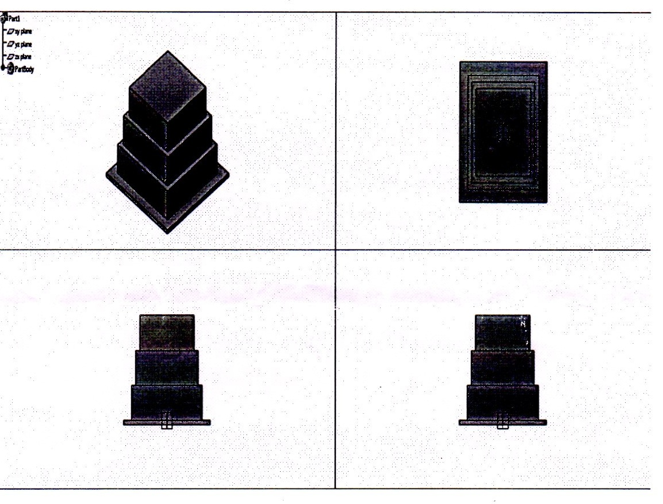

Figure 5: Design Drawings

Length (fore/aft direction): 260_mm (>=200mm)

Width (lateral direction): 260mm (>=200mm)

Height (vertical direction): 240mm (>=100mm)

Attenuator is at least 200mm wide by 100mm high for at least 200mm: Yes

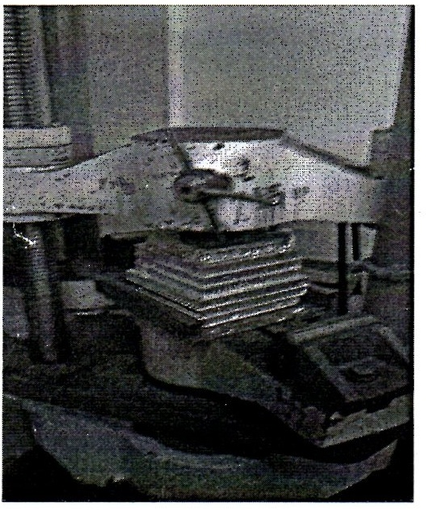 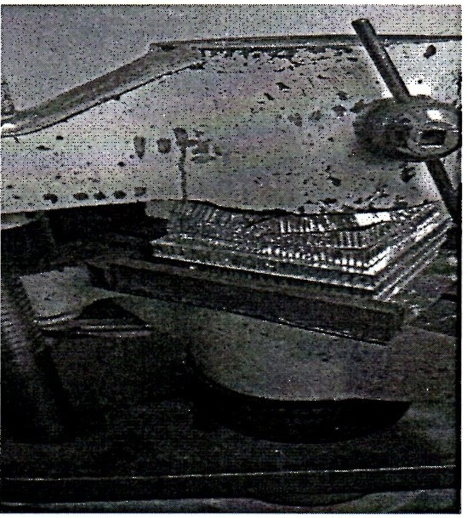

**Attenuator before and after the test**